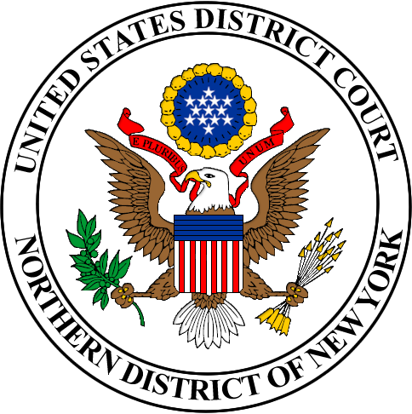

PUBLIC NOTICE FOR THE
APPOINTMENT OF MAGISTRATE JUDGE

The Judicial Conference of the United States has authorized the appointment of a full-time United States Magistrate Judge for the Northern District of New York at Albany, New York. The essential function of courts is to dispense justice. An important component of this function is the creation and maintenance of diversity in the court system. A community’s belief that a court dispenses justice is heightened when the court reflects the community’s diversity.

The duties of the position are demanding and wide-ranging and will include: (1) presiding over most preliminary proceedings in criminal cases; (2) trial and disposition of misdemeanor and petty offense cases; (3) presiding over various civil and criminal pretrial matters and evidentiary proceedings on delegation from the judges of the district court; and (4) trial and disposition of civil cases upon consent of the litigants. The basic authority of a United States Magistrate Judge is specified in 28 U.S.C. §636.

To be qualified for appointment an applicant must

- Be, and have been for at least five years, a member in good standing of the bar of the highest court of a state, the District of Columbia, the Commonwealth of Puerto Rico, the Territory of Guam, the Commonwealth of the Northern Mariana Islands, or the Virgin Islands of the United States, and have been engaged in the active practice of law for a period of at least five years; (with some substitutes authorized).

- Be competent to perform all the duties of the office; be of good moral character; be emotionally stable and mature; be committed to equal justice under the law; be in good health; be patient and courteous; and be capable of deliberation and decisiveness.

- Be less than seventy years old; and

- Not be related to a Judge of the District Court.

A Merit Selection Panel composed of attorneys and other members of the community will review all applicants and recommend to the district judges in confidence the five persons it considers best qualified. The Court will make the appointment following an FBI full-field investigation and an IRS tax check of the applicant selected by the court for appointment. The individual selected must comply with the financial disclosure requirements pursuant to the Ethics in Government Act of 1978 and the Courthouse Ethics Act (CETA) of 2021. An affirmative effort will be made to give due consideration to all qualified applicants without regard to race, color, age (40 and over), gender, religion, national origin, or disability. The current annual salary of the position is $223,836. The term of office is eight years.

Applications are available on the Northern District of New York’s website at www.nynd.uscourts.gov. Applications can also be obtained from the Clerk of the District Court at our staffed offices in Albany, Syracuse, Utica, Binghamton and Plattsburgh. Applications must be received May 31, 2024.

All applications will be examined only by members of the Merit Selection Panel and the Judges of the District Court. The panel’s deliberations will remain confidential.

THE DISTRICT COURT IS AN EQUAL OPPORTUNITY EMPLOYER

